I C J E V A Q I P W B C I J R Q F V I F A Z C P Q Y M J A H N G F

Y D H W E Q R N A R E L K B R Y G P C S P K W B U P G K B K Z W D

S Z X S A F Z L O I W E T V P S I T Q I S O T F K K V T Q P S E O

W K P V R L J I E C H O H I T F P S U D X X A R C L J S N L U B O

I P R J H Y P I E F J E R B T V M U Q O I J Z A G Y L O H S E O H

W J F C L J G G T W A C W E K E G K Z N A S G E K A I E T W A R J

E D P S J Y H Q H I L O E B K S H A J V Y W K T K S L O B F E V Q

Q T P H Z W E R Z A A R V H I S O T F K O G C R L C J L O K T R Y

D H Z Z L Q Y S F Y W D S W Z O H C N T Q C P R D L O A R V H S O

I E R C S K S H N A R V H L S R N H P C X P W D S I L P L Z V Q L

J O E N L W Z J F S L C I E D J R R Y X J R V C V P O E O L J U F

Y R Q F G L U P H Y L W I S O T F K W J E R N S T Z Q M I V C W D

S C Z V P H V C U E H F C B E B K P A W G E P Z I S O T F K O E O

D N W Q Z Q W H Y P V A H K W H I S E E G A H R T O E G C P I P H

F J R Q

English Letter Frequency (based on a sample of 40,000 words)

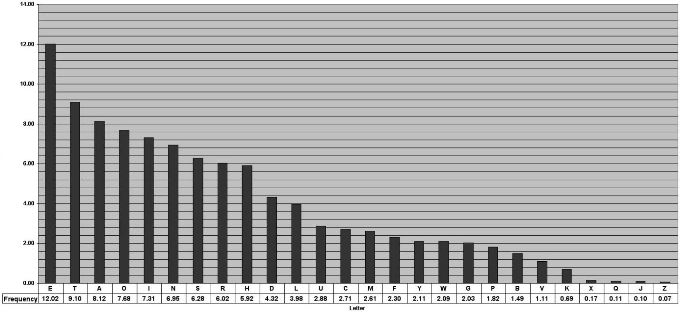

Answer:
The Keyword is "WORLD" and some strings that you may have found are: "ISOTFK", "ARVH", and "WDS". The content of this message is:
"Most Secret
"For Your Excellency's personal information and to be handed on to the Imperial Minister in Mexico
"We intend to begin unrestricted submarine warfare on the first of February. We shall endeavor in spite of this to keep the United States neutral. In the event of this not succeeding, we make Mexico a proposal of an alliance on the following basis: Make war together, make peace together, ample financial support, and an understanding on our part that Mexico is to reconquer the lost territory in Texas, New Mexico, and Arizona. The settlement detail is left to you."
Reference:
Polyalphabetic Substitution Ciphers (March 18, 2004), University of Cornell
https://www.math.cornell.edu/~mec/2003-2004/cryptography/polyalpha/polyalpha.html#examples

